Grants Funded
2022-2024 Biennium
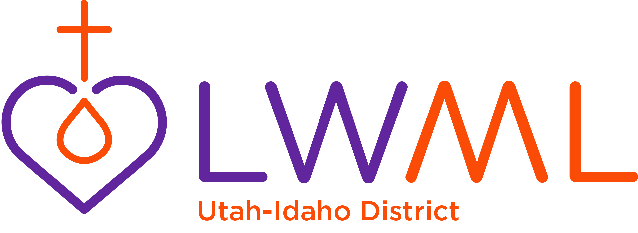

Grant Name | Amount Granted | Funded
Let it Snow Van. Get the track and watch the mission Grow.  Camp Perkins Outdoor Ministries, Hailey, Idaho | $5,000
Joyful Noise Learning Center,  Clover Trinity Lutheran Church, Buhl, Idaho | $2,000
Worship Anew—Open Arms in Mission  Peace Lutheran Church, Filer, Idaho | $5,000
Living by Faith, Not by Sight.  Lutheran Braille Workers, Idaho Falls, Idaho | $5,000
Comfort Dog Ministry,  Trinity Lutheran Church and School  Hicksville, New York | $2,500
Worker Wellness for Chaplain Families  LCMS Ministry to the Armed Forces  St. Louis, Missouri | $3,000
Environmental Play Place  Concordia learning Center  Holy Trinity, Riverton, Utah | $2,000
Sowing in our School  Hope Lutheran Church and School  Idaho Falls, Idaho | $2,000
Feeding Haitian Children Physically and Spiritually  Trinity Hope, Mount Juliet, Tennessee | $3,000
Two (2) year old Pre-school  Grace Lutheran Church and School, Sandy, Utah | $2,000
Different Languages, Same Savior,  Lutheran Books for Missionaries Around the World  Lutheran Heritage Foundation, Macomb, Michigan | $3,000
Making Immanuel Lutheran Child Development  Center more Lutheran  Immanuel Lutheran CDC, Twin Falls Idaho | $2,000
Jesus’ Love Transforms Lives in the Good Shepherd (Group) Home in the Dominican Republic, Hogares Luterano el Buen Pastor  St. Louis, Missouri | $2,500
In Every Language Funding Translators  MOST Ministries, Ann Arbor, Michigan | $2,500
XrossWay Disciple Makers Conference  XcrossWay Lutheran Ministries, Twin Falls, Idaho | $2,500
Total | $44,000

