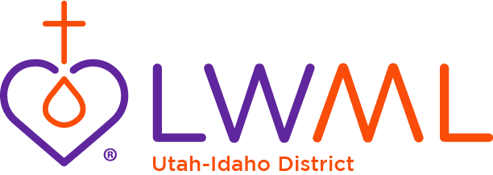

Date

Name of new church worker
Address

Dear (insert name),

It is with great joy that the women of the Lutheran Women’s Missionary League (LWML) Utah-Idaho District welcome you to our district! We look forward to getting to know you and working with you.

The LWML is an official auxiliary of The Lutheran Church—Missouri Synod (LCMS). As Lutheran Women in Mission, we joyfully proclaim Christ, support missions, and equip women to honor God by serving others. We endeavor to be an organization that is relevant and appealing to all LCMS women. The heart of our organization draws us closer to God through His Word, reaches out to others through service and fellowship, and furthers the spread of the Gospel by our financial support of missions and ministries through Mite Box offerings.

We are pleased to provide this packet of basic information for you. The flier included with this packet has information on items available from LWML. We encourage you to explore the LWML website, lwml.org, for more details. The website includes a special page just for church workers. If you are looking for a specific topic or item, we suggest using the search tool with key words. Many other downloadable doctrinally reviewed devotions and Bible studies can be found, too.

LWML strives to develop a greater mission consciousness in the church and community through prayer, service, fellowship, and Bible study. We hope you find this packet and the website useful to you in your ministry. Please contact me or another LWML district, zone, or local group leader with any questions you may have.

TO GOD BE ALL GLORY AND PRAISE!

Serving the Lord with gladness,

Terri Bentley, President
LWML Utah-Idaho District
208-861-7871
terribntly@gmail.com
utahidaholwml.org

Living in the Light
For God, who said, “Let light shine out of darkness,” has shone in our hearts to give the light of the knowledge of the glory of God in the face of Jesus Christ. 2 Corinthians 4:6

