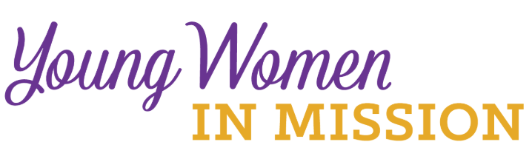
Young Woman Representative Application
Date: ____________

Convention Location: __________________________
Name_____________________________________ Age ______________
Address _____________________________________________________
City _____________________________ State _________ Zip ___________
Occupation ____________________________________________________
Home Congregation ______________________________________________
Phone _______________________ email __________________________
Please answer the following questions. Use a separate sheet of paper if needed.
Return to your district president.
1) The LWML motto is “Serve the Lord with gladness” (Psalm 100:2). How do you do this in your life?
2) What groups and activities are you involved in or have you been involved in at your church?
3) What do you know about the LWML? Have you been involved at any level?
4) Why do you desire to be a Young Woman Representative for the district?
5) What do you feel your special interests, talents, and gifts are?
6) Will you commit to serve in some capacity in your district after the convention?

Your district is making a financial commitment to send you to the LWML convention.
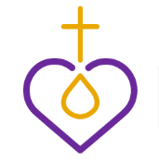
It will be an exciting and spiritually inspiring event with very little free time. You are expected to participate in the full scope of the convention. Are you able to do so?

You will also be asked to speak about your national convention experience at the 2020 district convention in Boise, write an occasional article from the YWR perspective for the U&I Together district newsletter, and speak at zone events if invited. Are you willing and able to carry out these responsibilities?

Please have someone who knows you well, perhaps the person who encouraged you to apply, answer the following question, “Why do you feel this woman would make a good Young Woman Representative?” Have them attach this answer on a separate sheet of paper along with their name and relationship to you.

