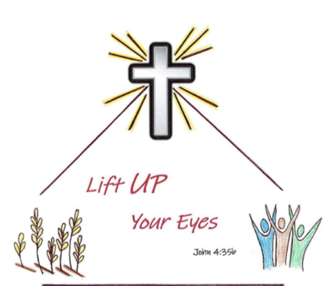
Registration Form
Utah–Idaho District LWML Convention, April 24–26, 2020
Concordia University School of Law
501 W. Front Street; Boise, ID 83702 (entrance on Broad Street)
Badge Name
Email Phone
Mailing Address
City, State, Zip
Look, I tell you, lift up your eyes, and see that the fields are ripe for harvest (John 4:35b).
Zone Church

Registration Category (check only one) |  | Interest Sessions, one during lunch and one during dinner. Choose 2. (Note: YWRs are invited to attend Karla Koehler’s lunch session.)
General Registration
Voting Delegate |  | Missionary Journeys by Kay Kreklau
Voting District Board Member |  | LWML Representative: Karla Koehler
Non-Voting District Board Member |  | Bible Study with Beth Foreman
Past District President |  | From Jerusalem to Samaria to Your Cul-de-Sac with Dr. Nancy Almodovar  Stretching for Strength with Leslie Wills
Young Woman Representative (YWR)
Pastor
Lunch Sandwich (circle one) Turkey Ham Veggie (served with salad, fruit, cookies).
(Dinner is buffet – pulled pork or turkey, coleslaw, beans, rolls, dessert)
Special dietary/physical needs:
Are you attending your first District Convention? Yes ___ No ___
Cost (includes lunch and buffet supper on Saturday)
Early Registration (postmarked by April 10) | $65 | $
Registration (postmarked after April 10) | $75 | $
Additional Family Member (meals only) | $35 | $
Total amount due |  | $ | No refunds after April 10
Make checks payable to: Grace Lutheran Caldwell
Send registration form and payment to:  Barb James  2812 E Ohio Ave.  Nampa, ID 83686 | Registration questions? Email Tonya Barber at tmlbarber@msn.com  General questions? Email Betty Reimann at breimann65@gmail.com

Individuals are responsible for their own lodging. A block of rooms has been reserved at the Hampton Inn & Suites, 495 S Capitol Blvd.; Boise, ID 83702. 208-331-1900. See Additional Registration Information page for details.

