BULLETIN BLURBS
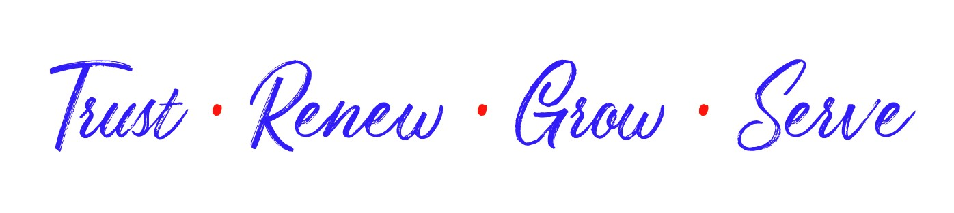
SAVE THE DATE! APRIL 29-MAY 1, 2022
Join your LWML sisters at the LWML Utah-Idaho District Convention in Burley, Idaho at the Burley Inn and Convention Center. Watch for more information in the U&I and at www.utahidaholwml.org
LWML UTAH-IDAHO DISTRICT CONVENTION
When: APRIL 29-MAY 1, 2022
Where: Burley Inn and Convention Center, Burley, ID
Bring your crafts for a Silent Auction Craft Sale to benefit the District’s Mission Grants.
Bring your party spirit to celebrate LWML 80th Anniversary.
Attend 2 Interest Sessions presented by Deb Burma, Rev. Gary Piepkorn, Rev. Roger Sedlmayr, or Dr. Nancy Almodovar.
Watch for more information in the U&I and at www.utahidaholwml.org.

LWML UTAH-IDAHO DISTRICT CONVENTION APRIL 29-MAY 1, 2022
Come and join Deb Burma in Bible Study. She will also be leading a break out session. Deb is an author for Concordia Publishing House and a sought-after speaker for women’s conferences, retreats, and ministry events. Her assortment of Christian-living books, Bible studies, and devotionals include the best-selling Bible study, Living a Chocolate Life, JOY: A Study of Philippians, and Be Still & Know: A Study of Rest & Refuge. Watch the U&I for more information and at www.utahidaholwml.org
LWML UTAH-IDAHO DISTRICT CONVENTION APRIL 29-MAY 1, 2022
Make plans now to come early for a special servant event.
On Friday April 29 from 1-3 p.m. you will have an opportunity to tour the Magic Valley Area Humanitarian Center in Rupert, and participate in an activity. The Center is located at 723 F Street, Rupert, Idaho. Watch the U&I or visit www.utahidaholwml.org for more information on ingathering items for the Humanitarian Center.
GOT PLASTIC?
Plastic grocery bags that is!
As part of the ingathering at the LWML Utah-Idaho District Convention in Burley, April 29-May 1, 2022 we will be gathering items for the Magic Valley Area Humanitarian Center in Rupert. One of the items they are requesting is plastic grocery bags. Members of the congregation can participate too! To help save space please fold the bags! Please see the U&I or visit www.utahidaholwml.org for more Gifts From the Heart information.
LWML UTAH-IDAHO DISTRICT CONVENTION APRIL 29-MAY 1, 2022
Friday April 29th Join together with your LWML Sisters and Brothers at Zion Lutheran Church in Burley for the Opening Worship with Holy Communion. The service begins at 7 p.m. with a reception following. Introduction of the YWRs and a short pinning ceremony will take place at the reception. Zion Lutheran Church is located at 2410 Miller Ave, Burley, Idaho. All are invited!

LWML UTAH-IDAHO DISTRICT CONVENTION APRIL 29-MAY 1, 2022
Convention offerings will be gathered at the Opening Worship service Friday evening and during the afternoon business meeting on Saturday afternoon. Convention offering #1 is designated for the District Mission Grants. Convention offering #2 recipients will benefit Lutheran Schools in Central Zone: Immanuel Lutheran School, Clover Christian School, and Eden Lutheran Preschool.
LWML UTAH-IDAHO DISTRICT CONVENTION APRIL 29-MAY 1, 2022
LWML is celebrating 80 years of mission service. We will be celebrating this special milestone on Saturday evening with Birthday Cake and LWML Trivia Game. So brush up on your LWML History!
Come and see our Purple and Gold Team Captains!!
Please pray for the members of the LWML Utah-Idaho District as they meet in convention soon. Members will be voting on mission grants, hearing inspirational speakers, and participating in servant activities. May all that is done be to the glory of God as they continue to serve the Lord with gladness.

