Approved Mission Grants
2020-2022 Biennium
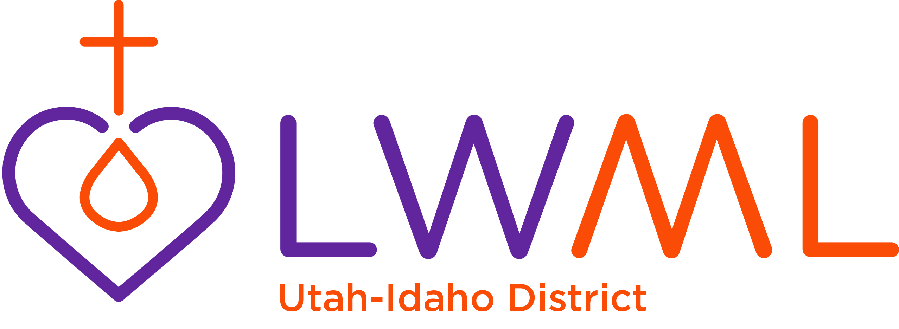

Grant | Amount | Funded
Food for Concordia Theological Seminary’s Food and Clothing Co-op – Ft. Wayne, Indiana | $5,000
MOST Ministries-Clean Water Filters | $3,000
Immanuel Lutheran School Scholarships for Students – Twin Falls | $5,000
Trinity Lutheran Preschool - Eden | $5,000
Bringing Light to Those Living in Darkness  (Lutheran Braille Workers) | $2,000
Equipping People with Intellectual and Developmental Disabilities to Share the Gospel (Bethesda) | $4,000
Care of Souls (DOXOLOGY) | $5,000
Bahamas Mission Trip  Grace Lutheran Church, Sandy, Utah | $2,210.50
Missionary Support: Rev. James and Deaconess Christel Neuendorf | $2,210.49
Total Mission Grants to be Funded | $33,420.99
Mission Grants Budget | $30,500
Unused Church Worker Grant – 2018-2022 | $2,000
District Convention Surplus - 2018 | $920.99
Total | $33,420.99

